RE: CTR iSolved Employee Portal Access

Dear Employees,

This e-mail contains instructions for gaining access to our employee portal. Our employee portal allows you to view and print your pay stubs, see pertinent team member and company information along with the ability to view and/or edit employee information. Please carefully read the following instructions before activating your employee account.

Look for an e-mail from ctr@myisolved.com. This e-mail will contain a link with instructions on activating your account. If you do not receive this e-mail, please check your Spam/Junk folder.
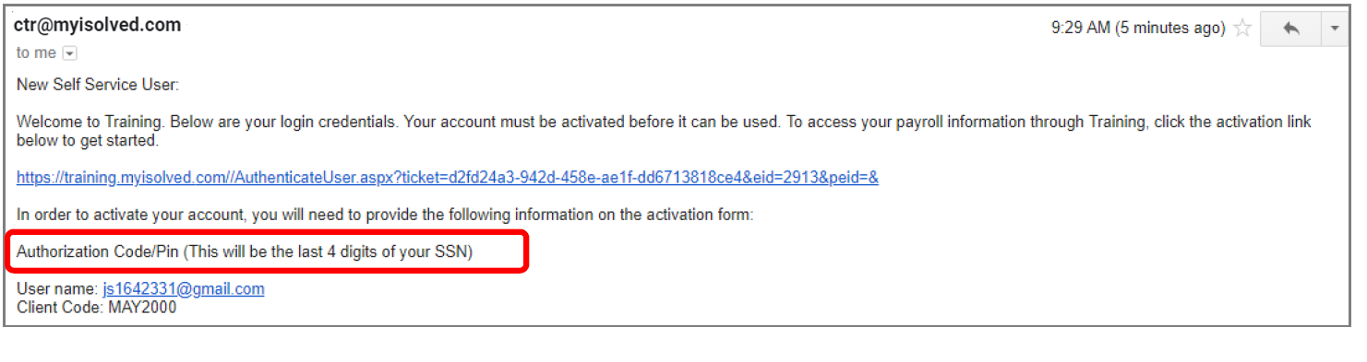
To activate your account:

Step 1: Click the link within the e-mail to begin
Step 2: Enter your authorization code-this is the last 4 digits of your social security number
Step 3: Complete the required fields including your challenge question and answer (Remember this question as this is how you will reset your password if you forget!)

After doing these 3 steps, you have activated your account. After activating your account, DELETE the activation e-mail as this link is no longer valid.

Now that you are activated, you will follow these steps to log in:
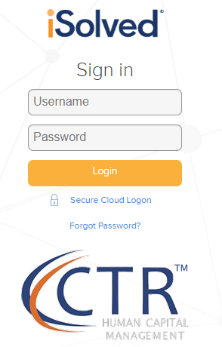
Step 1: Go to https://cohere.ctrhcm.com/UserLogin.aspx (save this link as a favorite or desktop icon)
Step 2: Enter your username (your e-mail address) and password you created during activation

Some important notes:
We recommend using the Chrome Web Browser for the best experience

If you forget your password, click “Forgot My Password” on the login screen. This will allow you to reset your password by answering the challenge question you originally set up. Please utilize this feature prior to contacting CTR Support

